Biology, Castle View High School
Dr. Jason R Mayberry
Study Guide: Polar Covalent Bonds
Vocabulary Summary
- Polar Covalent Bond
- Bonding Type Continuum
- Electron Cloud
- Electronegativity
Conceptual Questions
- Describe the difference between thinking of electrons as particles vs energy.
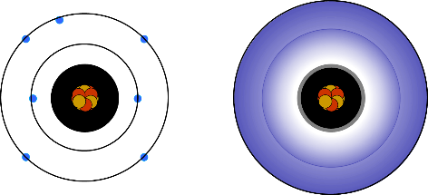
- Describe what happens to the energy of electrons involved in bonding when forming an ionic bond.
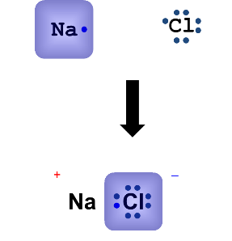
- Describe what happens to the energy of electrons involved in bonding when forming a non-polar covalent bond.
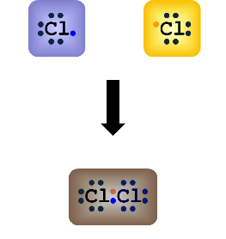
- Describe what happens to the energy of electrons involved in bonding when forming a polar covalent bond.
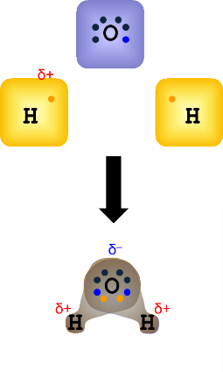
- Explain why atoms involved in polar covalent bods have partial positive and negative charges.

- Describe what is meant by the Continuum of Bonding Types
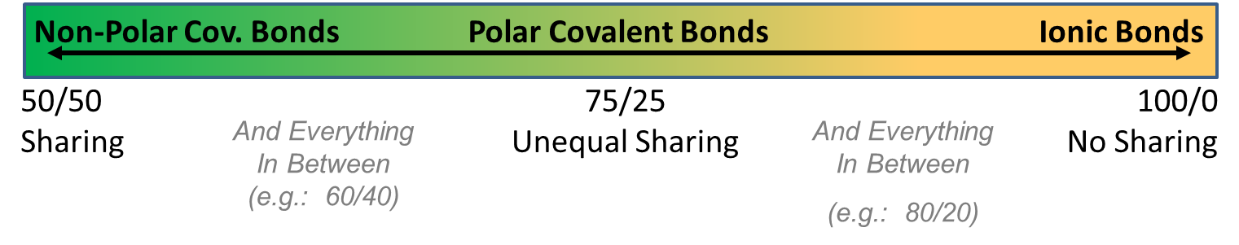

- What determines the strength of a chemical bond [as experienced in Biological (i.e aqueous) Systems].

- Describe generally how an atoms electronegativity is related to how close it is to having its octet
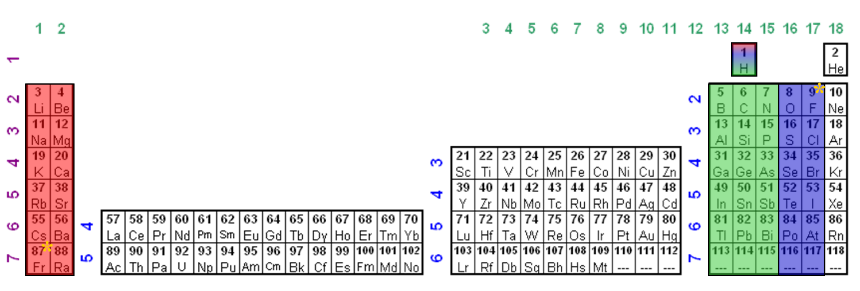
- Why in the above periodic table of electronegativities is H placed in the middle above C. What do they have in common?

- Explain how the relative electronegativities determines the type of bond that will form between two atoms.

- Classify each of the following as Non-Polar Covalent, Polar Covalent, and Ionic. Make sure you understand the reason for each.
  - C-C
  - C-H
  - HCl
  - KI
  - NaCl
  - NaI
  - N-H
  - O=O
  - O-H

